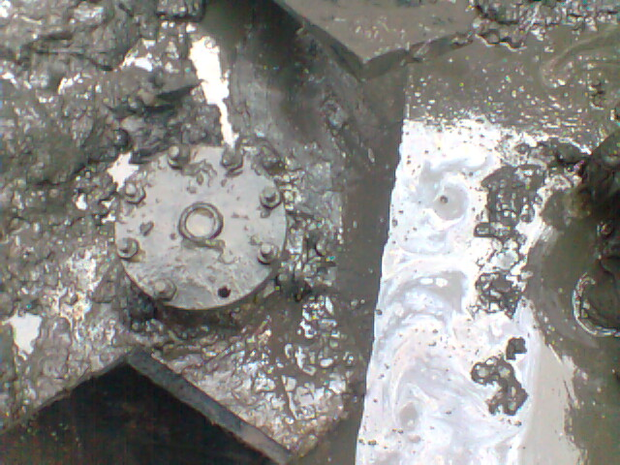
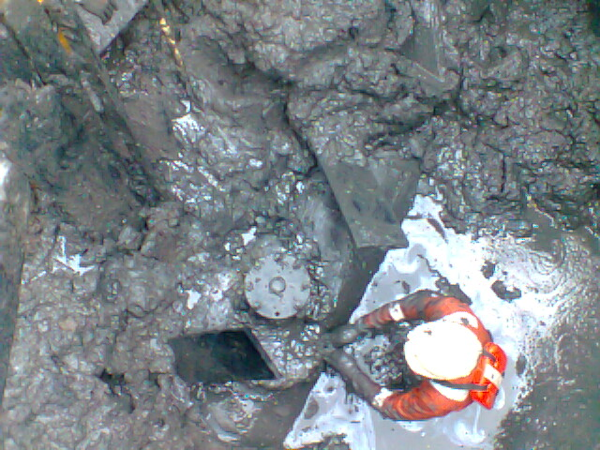
Picture showing the 6’’non-leaking theft point at 12o’clock position on the pipeline.

